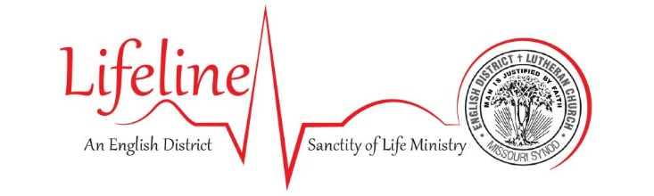
The nuclear family is one of God’s great First Article gifts to us and to all mankind! God joins one man and one woman in lifelong union, through which He creates, nurtures, protects and defends new lives. Parents are called to raise and educate their children to love and honor God and be of service to their neighbors. Children are called to honor their parents even into their old age. Indeed, it is in family that He declares the sanctity of life from fertilization to forever, and it is through His Church that He brings this message to the world.

Sadly, the nuclear family is under attack on so many fronts, from the very definitions of gender and marriage, to abortion, to the rearing of children, and to assisted suicide/euthanasia. We as God’s Church are called to respond. For this reason, your English District Lifeline team has selected Family as the overall AD 2023 Lifeline theme. In the coming months, look for resources on these topics:
- The gift of children
- Love and care within the family
- Chastity/sexual ethics
- Elder care
We pray that these will help equip you to support, encourage, and advocate for families, and thereby proclaim the sanctity of life in your congregation and community.

