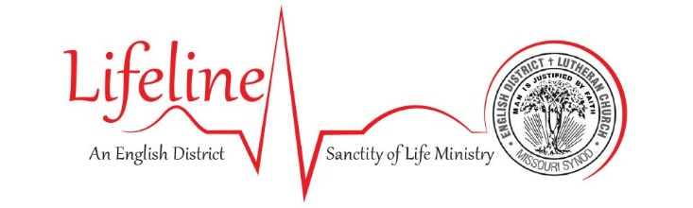
POST-ABORTION FORGIVENESS AND HEALING

Have you lost a child through abortion?
Have you been part of an abortion decision as husband, boyfriend, or family member?
Have you participated in abortion as a provider?
If so, are you experiencing the pain of guilt, regret, and grief?
Know that there is help available for you.

First and foremost, talk with your pastor! He is the man called by God to receive your confession and grant you His absolution, namely His forgiveness. Remember that Jesus died for the sin of abortion, too and rose again to declare you right with the Father (Romans 4:25). This means that once He forgives you, God no longer remembers that you sinned (Isaiah 43:25)! This is where your healing truly begins.

Next, recognize that you may be dealing with a form of post-traumatic stress disorder called post-abortion syndrome (PAS). This means that even after receiving God’s forgiveness, you may need ongoing counselling. We commend Word of Hope, an outreach of Lutherans for Life, providing help and healing through the lens of Scripture and our Confessions. Note that the Word of Hope counsellors work closely with your pastor. They may be reached at https://word-of-hope.org, or by calling 1-888-217-8679. Additionally, many life-affirming pregnancy care centers offer PAS counselling; you may find one in your area through the networks of Care Net (http://www.care-net.org) and Heartbeat International (https://www.heartbeatinternational.org).

Additional information is available at https://lcmslife.org/tags/post-abortion/ and https://lutheransforlife.org/life-issues/after-the-abortion/.

And, of course, your English District Lifeline team is always available to you! Know that we love you, care for you, and pray God’s healing peace on you.
POST-ABORTION FORGIVENESS AND HEALING

Have you lost a child through abortion?
Have you been part of an abortion decision as husband, boyfriend, or family member?
Have you participated in abortion as a provider?
If so, are you experiencing the pain of guilt, regret, and grief?
Know that there is help available for you.

First and foremost, talk with your pastor! He is the man called by God to receive your confession and grant you His absolution, namely His forgiveness. Remember that Jesus died for the sin of abortion, too and rose again to declare you right with the Father (Romans 4:25). This means that once He forgives you, God no longer remembers that you sinned (Isaiah 43:25)! This is where your healing truly begins.

Next, recognize that you may be dealing with a form of post-traumatic stress disorder called post-abortion syndrome (PAS). This means that even after receiving God’s forgiveness, you may need ongoing counselling. We commend Word of Hope, an outreach of Lutherans for Life, providing help and healing through the lens of Scripture and our Confessions. Note that the Word of Hope counsellors work closely with your pastor. They may be reached at https://word-of-hope.org, or by calling 1-888-217-8679. Additionally, many life-affirming pregnancy care centers offer PAS counselling; you may find one in your area through the networks of Care Net (http://www.care-net.org) and Heartbeat International (https://www.heartbeatinternational.org).

Additional information is available at https://lcmslife.org/tags/post-abortion/ and https://lutheransforlife.org/life-issues/after-the-abortion/.

And, of course, your English District Lifeline team is always available to you! Know that we love you, care for you, and pray God’s healing peace on you.

